AI CLUB — VIT CHENNAI
NIS-01: NEURAL INTELLIGENCE SYSTEM
Concise Visual Brand Identity Guide

1. Core Concept
Human Intelligence × Artificial Intelligence
The identity combines organic neural forms with precise computational/circuit elements, reflecting AI, technology and human creativity.

2. Brand Personality
Intelligent · Technical · Modern · Creative · Human · Clean
Technologically advanced without becoming overly futuristic, cyberpunk or cluttered.

3. Colour Palette
Colour | HEX | Primary Use
Electric Blue | #3187E8 | Main accent, CTA, highlights
Light Blue | #69ACFF | Gradients, secondary accents
Deep Navy | #0B1726 | Dark backgrounds
Navy Surface | #14283D | Dark cards/sections
Tech Grey | #969696 | Secondary graphics
Light Grey | #E8EDF3 | Borders/cards
Off White | #F7F9FC | Main light background
White | #FFFFFF | Cards/text
Blue functions primarily as an accent; neutral space should remain dominant.

4. Typography
- Primary — Space Grotesk: headings, titles, navigation and major statements.
- Secondary — Inter: body text, descriptions, UI and event information.
- Technical — JetBrains Mono: small technical labels and event identifiers.

5. Graphic Language
- Core motif: Neural Nodes + Circuit Lines + Technical Grid.
- Circuit lines: 1–2 px, using 90°/45° turns and circular nodes.
- The blue circular node (●) is a recurring signature element.
- Organic curves connect the visual language to the brain/neural side of the logo.

6. Layout & Spacing
- Website: 12-column desktop grid; 4-column mobile grid.
- Posters: approximately 6-column grid.
- Spacing follows an 8 px base system: 8 · 16 · 24 · 32 · 48 · 64 · 80 · 96 px.
- Strong alignment, clear hierarchy and generous negative space.

7. Shapes & Components
- Cards: clean/minimal, ~12 px radius, subtle borders and occasional circuit details.
- Buttons: primary #3187E8 with white text and 8 px radius; secondary uses a blue outline.
- Icons: minimal outline style, 1.5–2 px stroke, geometric and consistent.
- Rounded UI elements contrast with angular circuit geometry.

8. Website Style
- Hero: large typography with a brain/circuit visual.
- Events: structured cards with dates, categories and event identifiers.
- Projects: technical/grid-based layouts.
- Team: photography with subtle circuit overlays.
- Join Us: strong blue CTA. Light background #F7F9FC; dark sections #0B1726.

9. Dark Mode
- Background #0B1726 · Surface #14283D · Text #FFFFFF.
- Secondary text #A9B5C2 · Accent #3187E8.
- Suitable for hackathons, technical events, project showcases and special campaigns.

10. Animation
Signal → Connection → Activation
Nodes appear → circuits connect → content activates. Motion remains subtle, precise and controlled.
- Micro interactions: 150–250 ms · Standard transitions: 300–500 ms · Hero animations: 600–1000 ms.

11. Event Identification
Consistent technical identifiers may be used across posters, website cards, presentations and social media.
AI CLUB // [CATEGORY]-[NUMBER]
- WS — Workshop · TL — Talk · HC — Hackathon · CP — Competition · PR — Project

12. Poster Identity
Strong typography + generous whitespace + neural circuitry + structured information + blue accents. The brain-to-circuit visual remains the primary hero graphic while event information stays clean and readable.

13. Gradient
linear-gradient(135deg, #3187E8 0%, #69ACFF 100%)
Use selectively for hero accents, special headings, primary CTAs, interactive states and event graphics.

14. Brand Formula
Organic Intelligence + Computational Precision + Human Creativity
Space Grotesk + Inter + Electric Blue + Deep Navy + Neural Nodes + Circuitry + Grid + Negative Space

15. NIS-01 Principle
One visual language, many applications.
The system applies consistently across posters, website, Instagram, presentations, certificates, reels and merchandise. Layouts may vary while colour, typography, graphic language and overall visual character remain consistent.
16. Poster Theme/Template
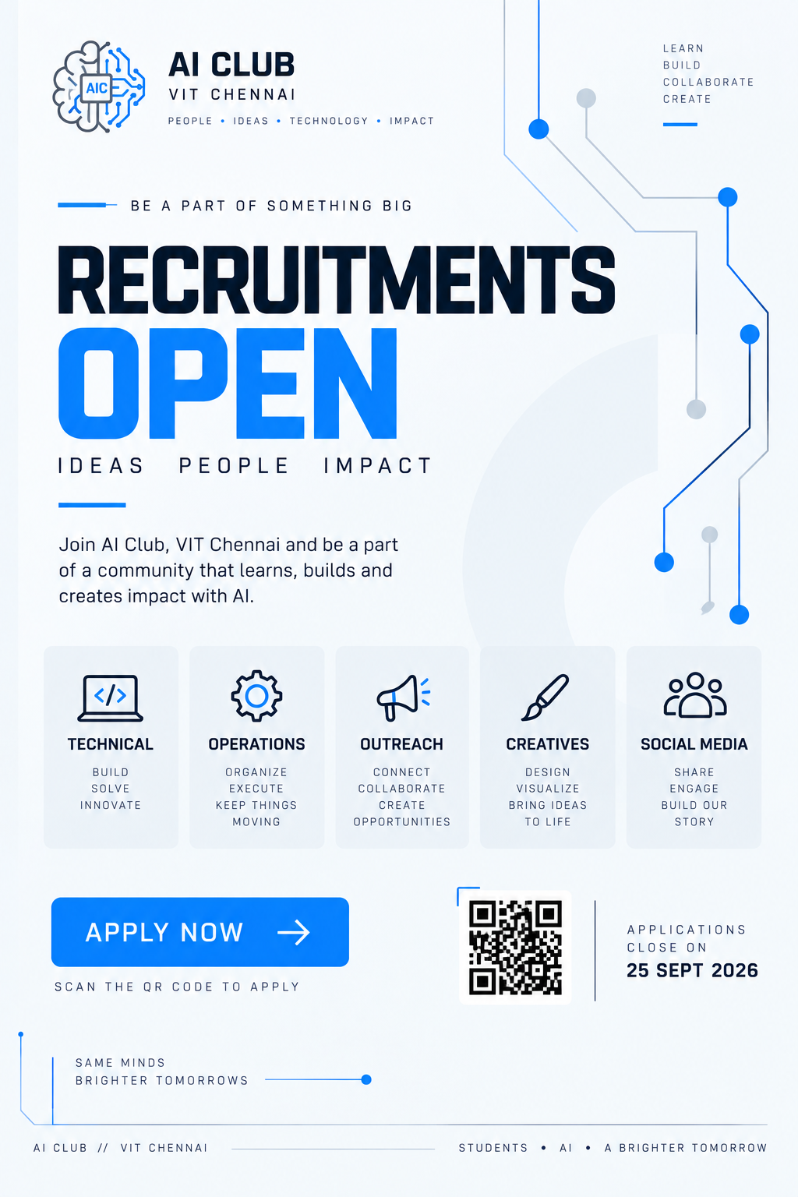
16. Website Theme/Template
